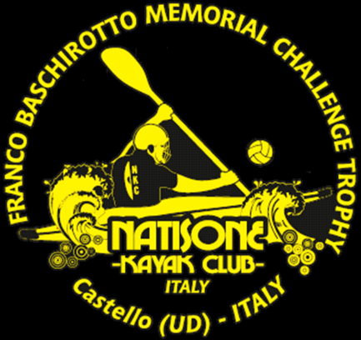 | TEAM REGISTRATION FORM  4° SUMMER TRAINING CAMP 2019  Castello di Porpetto (UD) Italy  MONDAY 8 JULY - FRIDAY 12 July 2019

CLUB/TEAM INFORMATION
TEAM NAME
PERSON RESPONSABLE
CONTACT PHONE NUMBER
E-MAIL
DATE OF ARRIVAL
DATE OF DEPARTURE
NUMBER OF PERSONS IN GROUP
SPECIAL PRICE DAILY ‘MEALS DEAL’ OFFER | € 30 FOR EACH PERSON PER DAY (Breakfast + Lunch + Dinner)
NUMBER OF PERSONS FOR ‘MEALS DEAL’
DATES FOR USING ‘MEAL DEAL PLAN’
INTENTION TO PLAY IN THE TOURNAMENT | □ YES | □ NO
ONE-TIME CAMPING FEE € 20 FOR EACH TEAM
Payment to Natisone Kayak Club: BANCATER CREDITO COOPERATIVO FVG - IBAN IT19Z0863163930000000855696.
Please specify on payment receipt ‘Registration for 4° SUMMER TRAINING CAMP WEEK 2019’ Proof of payment fees must be sent in advance within 30th June 2019
Return this filled out form to: natisonekayakclub@gmail.com

TO REGISTER IN THE 30° FRANCO BASCHIROTTO MEMORIAL 2019 INTERNATIONAL TOURNAMENT
PLEASE GO TO THE 30° FRANCO BASCIROTTO MEMORIAL 2019 PAGE ON OUR WEBSITE
TO DOWNLOAD THE REGISTRATION FORM

REGISTRATION FEE: € 100 for each team.

Payment to Natisone Kayak Club: BANCATER CREDITO COOPERATIVO FVG - IBAN IT19Z0863163930000000855696.
Please specify on payment receipt ‘Registration for 30° Franco Baschirotto Memorial 2019’ and playing division. Proof of payment fees must be sent within 30th June 2019 to guarantee participation in the Tournament.

Free commemorative ‘30° Anniversary Edition’ polo shirts for all teams that register before 30 May 2019.
POLO SHIRT SIZES: 2XL, XL, L, M, S
Free Tournament club tee-shirts will also be given to the athletes from first-time club registrations
TEE SHIRT SIZES: 2XL, XL, L, M, S

Return this filled out form to: natisonekayakclub@gmail.com within Sunday 7 July 2019. Thank you.

